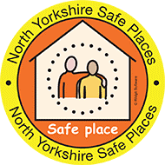
Top Tips for Safe Places organisations

These Top Tips were developed by self-advocates from the North Yorkshire Learning Disability Partnership Board.
They give ideas for organisations who are part of the Safe Places scheme on how to support people with a learning disability or autism.

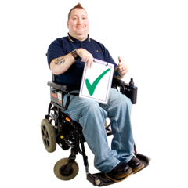 | Understand what the Safe Places scheme is and why it is important  You can find out about the Safe Places Scheme at https://www.northyorks.gov.uk/safe-places
 | Help the person to feel comfortable as they may be anxious or upset
 | Don’t rush, stay calm and take time to listen,

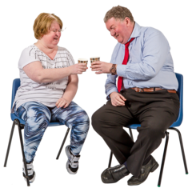 | Ask if the person would like to sit down and offer them a drink.
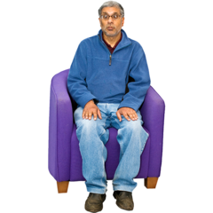 | We may want a quiet place to sit if the place is crowded or noisy.
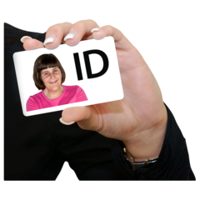 | Ask if they have a Safe Places ID card or a phone number of someone to contact.
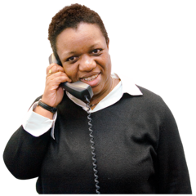 | Offer to call the number we have given you.
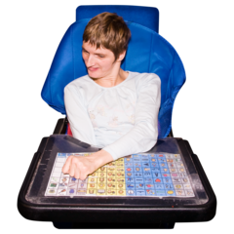 | Some people may struggle to communicate  They may have a card with pictures or symbols on it which they can point to.
Made by North Yorkshire Learning Disability Partnership Board – April 2020

